**Unit: Manual Motor Controls Test: 4**

**Basic Motor Controls and Single-Phase Motors CLO#: 1**

Name ______________________________ Date ______________

**Instructions**

Identify each component of the AC single-phase motor.

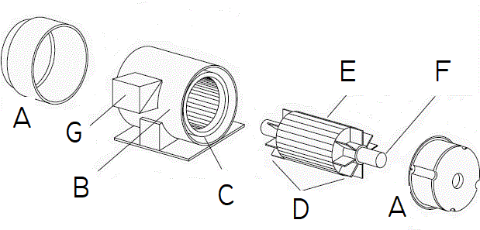

|  |  |  |  |
| --- | --- | --- | --- |
| 1. Fans |  | 1. Stator |  |
| 1. Terminal Box |  | 1. Shaft |  |
| 1. Windings |  | 1. End Bells |  |
| 1. Rotor |  |  |  |

1. What is the term used in the field for the Single-Phase AC induction motor that we are using in class?
   1. Rat cage
   2. Hamster wheel
   3. Squirrel cage
   4. Mouse trap
2. What is the field term for the terminal box on the side of a motor?
   1. Dim-head
   2. Pecker-head
   3. Knock box
   4. Hot box

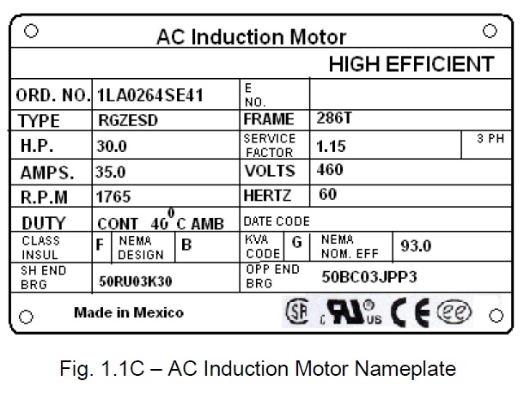

1. What is the horsepower for this motor? __________
2. How many watts should this motor dissipate? ______________
3. What nominal voltage level would you use to connect to this motor? ___________
4. What is the acceptable range of voltage input to this motor? _______ to _______
5. What is the RPM for this motor? ____________
6. If the motor is running at the minimum voltage that you calculated above, it would spin at a slower RPM?
   1. True
   2. False
7. What is a safe and acceptable way to vary the speed of this motor?
   1. Decrease the voltage
   2. Limit the current
   3. Vary the frequency
   4. Motor speed cant be change.

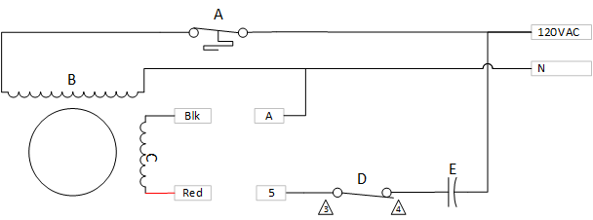

1. Match the components in the above single-phase motor schematic to their components.
   1. ______________ Start Switch
   2. ______________ Capacitor
   3. ______________ Thermal Switch
   4. ______________ Run Windings
   5. ______________ Start Windings
2. If the motor is running CW with Blk wired to 5 and Red wired to A, how should the motor be re-wired to obtain a CCW rotation?
3. Explain why re-wiring this winding causes the motor to rotate in the opposite direction?
   1. AC is flowing in the other direction
   2. The poles of the start windings are reversed
   3. A switch inside the motor is changed
   4. The capacitor is reversed in the circuit
4. This motor can change its rotation while running.
   1. True
   2. False
5. How does having a capacitor in the circuit cause the motor to rotate in one direction or the other?
   1. There is a phase shift where voltage leads the current
   2. The capacitor changes the direction of current
   3. These is a phase shift where current lead the voltage
   4. The capacitor does not help change direction
6. An AC induction motor has a permanent magnet that creates the magnetic field.
   1. True
   2. False
7. Mark up the drawing of a stop/start circuit below to correct any issues/omissions.

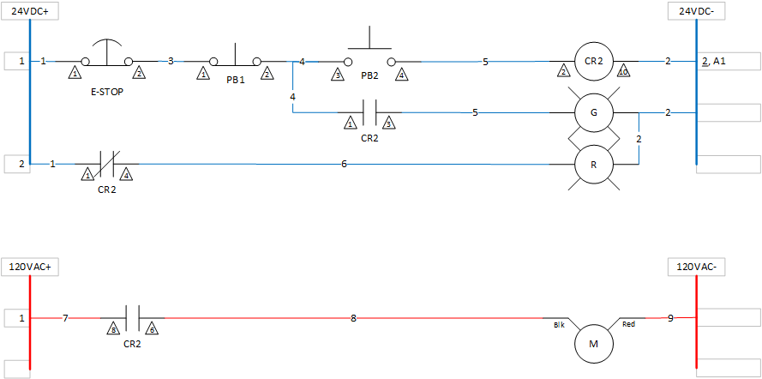

For the below drawing, calculate how many states it shall have, build a truth table and compose a formula.

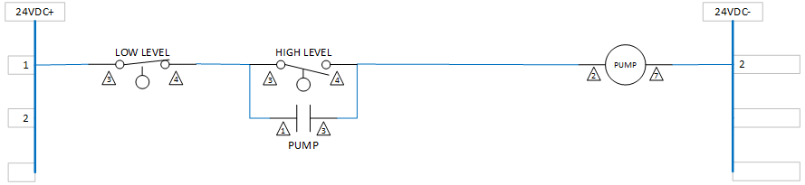

|  |  |  |
| --- | --- | --- |
| Low Level | High Level | Pump |
|  |  |  |
|  |  |  |
|  |  |  |
|  |  |  |
|  |  |  |